MASS CASUALTY PLAN
FORBDRCS/IFRC EMERGENCY HOSPITAL, BANGLADESH
March 8th 2018

The “Guideline for Emergency Hospital’s Public Relations and Relationship with Authorities”, which purpose is to ensure enhanced security arrangements, public relations and communications among IFRC, BDRCS and Emergency Hospital Team leaders, must be consulted if a mass casualty event occurs.
Medical roles and assignments will vary with the number of staff available in the camp, the number of patients and the severity of patients. Depending on the situation, you may be reassigned to a different area and a different function.
- The Team Leader is the focal point for overall decisions.
- The Deputy Team Leader (DTL) is the focal point for radio-communication and coordination.
- The Senior Medical Officer (SMO) is the focal point medical decisions.
- The Head Nurse is the focal point for health HR.
- The Lead Tech is the focal point for non-health HR
When to activate: | If 4 or more Red: Highest priority (Massive bleedings/Breathing/  Chest/injuries/Massive wounds or 8 Yellow: Delayed priority  up to 8 different colours casualties.
How to activate: | Triage (or any first responders) to contact Team Leader (TL), Deputy Team-Leader (DTL) and Senior Medical Officer (SMO) via radio.
SMO to activate: | Mass Casualty Plan
Radio message: | “All stations - All stations - Mass Casualty - Meeting point 2 immediately” x 3 times
Meeting point: | In the gate outside X-ray
TL | - Contact BDRCS coordinator at the Emergency Hospital who will contact relevant local authorities immediately (e.g. police, fire brigade, health authorities, Intelligence). If BDRCS coordinator is not reachable TL will call relevant local authorities directly.  - Contact IFRC HoD and IFRC Security. IFRC Security delegate to come to the field hospital immediately.
TL/SMO | Give short sit rep/All delegates go to pre-assigned stations to see to designated patients
Security guard: | Allow only ambulances with only one caretaker per patient to enter the triage area. Other caretakers or relatives must wait in the waiting area in front of OPD.  Doing crowd control.
Triage: | - Red - Highest priority (Massive bleedings/Breathing/  Chest/injuries/Massive wounds  - Yellow - Delayed priority  - Green – Ambulant priority  - Black –minimal chance of survival - Dead  - Waiting area caretakers/family
Stations: | - OFF LOADING AREA  - Triage just inside entrance gate.
- RED AREA
- Operation theatre 1 and 2
- Maternity
- YELLOW AREA
- OPD tents
- GREEN AREA
- PSS tent
- BLACK AREA
- Maternity
- Morgue
- PATIENT FLOW FROM 4 UP TO 20 PATIENTS

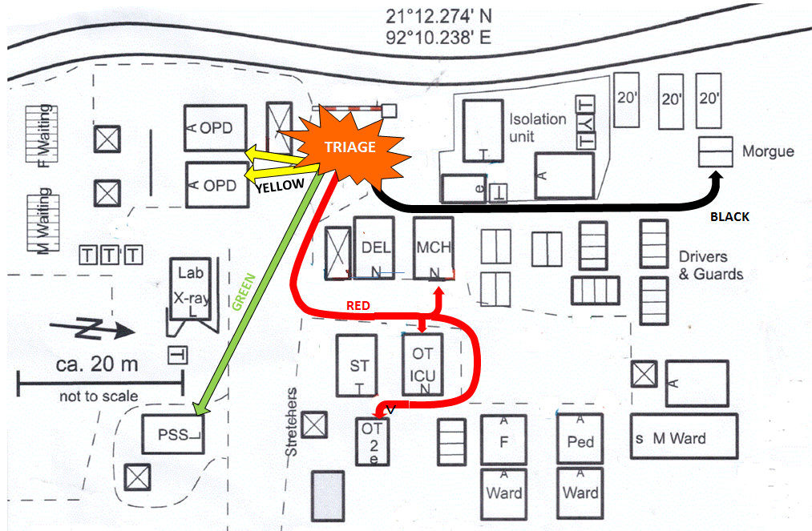

2. Coordination Medical staff
Profession | Location | Role
TL | On site/admin tent | Overall decisions, coordination and external contacts in cooperation with BDRCS Administrator at Emergency Hospital. See procedure at page 1.
DTL | On site/admin tent | Coordinate radio communication  Coordinate evacuation chain  Overall security and crowd control
SMO | Gate | Triage with anaesthetic nurse, allocation of teams of three health workers to each red patient.
Head Nurse | Ambulating | Responsible for establishing teams of three and three in first phase.  Responsible for counting available beds.  Initiate discharge of patients from ward according to needs in cooperation with local doctors/staff
OPD nurses | OPD | Two OPD nurses allocated to OPD when first yellow patient has arrived  The others to be a part of teams, allocated by SMO/head nurse
Midwife | Maternity | One midwife responsible for emptying maternity, bringing patients to the female ward  The rest participates in groups of three.
GP | First OPD, later PSS | One GP takes lead and coordinates treatment in OPD, for yellow patients. Perform re-triage, reallocate patients when indicated  The rest participate in teams of three allocated by SMO/head nurse
Surgeon, Anaesthetist, gynaecologist, OT nurses, anaesthetic nurse | OT 1/OT 2/Delivery (red areas) | Assessment and treatment of patients, red area. Re-triaging, re allocate when indicated.  Reporting back to SMO
Local doctors and nurses | Wards | Discharge patients from wards. Close cooperation with head nurse. Assessment and treatment of patients in the wards.
GP, Nurses, local doctors,  PSS delegates | PSS tent | After initial triage, one GP takes lead at PSS tent. Assessment and treatment.  Re-triage and discharge where appropriate.
PSS delegates | PSS tent | In the initial phase be a part of teams of three.  After initial phase work in PSS tent, green patients
Maternity/Morgue  Nurse. Local staff. | Maternity/Morgue | Responsible for proper handling of dead and dying patients. Dying to the maternity, dead to the morgue  Identification.
Lab Technician | Lab | Lab tests as ordered  Blood Supply  Other duties based on need
X-ray Technician | X ray | X-rays as ordered  Other duties based on need
Pharmacy/Med log | Pharmacy | List of MCP drugs.  Hand out Emergency bags  Grab bag for medicines - additional drugs needed from cold chain.  Other duties based on needs

- Non-medical staff —Assignments will be based on need. Depending on the situation, you may be re-assigned to a different area and a different function.
FAD,  with TL and Log | Coordinates non-medical staff in waiting area for staff.  (In front of admin tent)
DTL / Hosp Adm | Arranges ambulance(s) and cars for transfers of patients. Arranges transport for discharged patients.
Translators | Translation
Lead Technicians | Create and coordinate stretcher teams
Technicians | Bring stretchers to triage area.  Available for stretcher transport/assist in patient flow. Assist with crowd control if necessary.  On standby for technical issues
Cleaners | Cleaning, collecting waste
Guards | Crowd control/Security control
Kitchen staff | Water and food
Laundry staff | Laundry

- Medication and equipment
Med log  Technician | Supply with medication and equipment  These items should be in OPD when Mass Casualty:  - Triage Forms (numbered)  - Plastic Covers for Forms  - Admission Sheets  - Clipboards  - Pens, Markers  - Clip Boards  - Stapler/Staples  - Tape  - Scissors  - Paperclips  - Bags for patients’. belongings  - Flashlight and headlights  These items should be brought to OPD, if not available:  - PPE – Gloves, Masks, Goggles  - Stethoscopes  - Oral Airways – Various sizes  - IV Infusion Sets  - IV Cannulas  - IV Solutions – Ringer`s Lactate  - Alcohol Swabs  - Syringes / Needles  - Basic Dressings – Gauze pads and rolls, Abd pads, Tape,  - Splints  - Slings  - Elastic Bandage  - Extra Lights  - Body Bags  - Tarps  Other Supplies  - Tables  - Benches  - Stretchers  - Buckets for water (burns)  - Jugs of Clean Water  - Emergency supply of foods  These items should be in PSS when Mass Casualty:  - Apron, Plastic, disposable 140 cm  - Bandage elastic, 10 cm  - Bandage elastic 5 cm  - Bandage arm sling 7,5 cm  - Bandage triangular  - Compress Gauze 10x10 non- sterile  - Compress, absorbent 10x20 sterile (Klinipress)  - Compress gauze 9x10 sterile 5e  - Container, safety 5l for used syrings and needles  - Disinfectant, hand 80% alcohol 600 ml  - Examination gloves. Nitrile, size L, M, S  - Rescue sheet, gold/silver  - Scissors straight sh/bl 13 cm  - Splint, universal  - Sphygmomanometer, aneroid, adult  - Stethoscope, double cup  - Thermometer, Celsius  - Waste bag 100l black, 72x112  - Band aid  - Tape  - Blankets  - Water bottles  - Plastic drinking cups

Deactivation of MCP | Responsible for decision is SMO  Debrief to be led by TL, SMO and PSS
Responsible for document | SMO in cooperation with head of surgery and anaesthesiology

